Data Intake Report

Name: Deployment on Flask

Report date: 28th June 2024

Internship Batch: LISUM34

Version:1.0

Data intake by: Biswadip Bhattacharyya

Data intake reviewer:<intern who reviewed the report>

Data storage location: <location URL eg: github, cloud>

**Tabular data details:**

|  |  |
| --- | --- |
| **Total number of observations** | 1000 |
| **Total number of files** | 1 |
| **Total number of features** | 7 |
| **Base format of the file** | .csv |
| **Size of the data** | 1. kb |

**1.Dataset:**

The Dataset provides a comprehensive view into the dynamics of online matchmaking interactions. It captures essential variables that influence the likelihood of successful matches across different genders.

**Variables:**

* **Gender:** 0 (Male), 1 (Female)
* **PurchasedVIP:** 0 (No), 1 (Yes)
* **Income:** Annual income in USD
* **Children:** Number of children
* **Age:** Age of the user
* **Attractiveness:** Subjective rating of attractiveness (1-10)
* **Matches:** Number of matches obtained based on criteria

**Target Variable:**

* **Matches:** Number of matches received, indicative of success rate in online dating

2. Investigation of data:

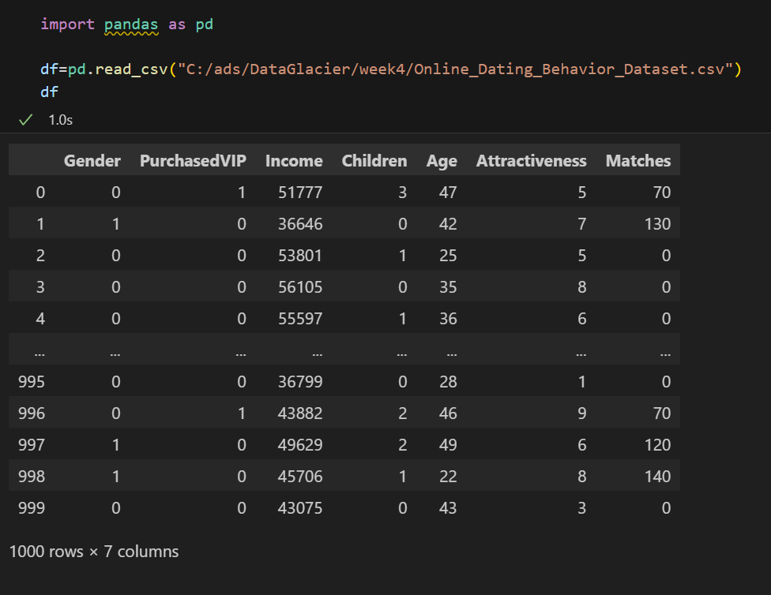

**3.** Model building:

**4. app.py**

**Index.html**

**CSS**

**5. Deployment of web app:**

